**PRACTICAL-7**

**Sharding**

Name-Nishi Patel

Roll No.- L003

**Step 1: Create Database Folders (Primary,Secondary1,Secondary2).**

-Open MongoDB terminal (cmd) from bin, and follow the below commands:

*For primary: mongod --port 2717 --replSet "myReplicaSet" --dbpath "/data/primary"

*For Secondary1: mongod --port 2727 --replSet "myReplicaSet" --dbpath "/data/secondary1" *For Secondary2: mongod --port 2737 --replSet "myReplicaSet" --dbpath "/data/secondary2" #Note: Open three separate cmds for above three servers.

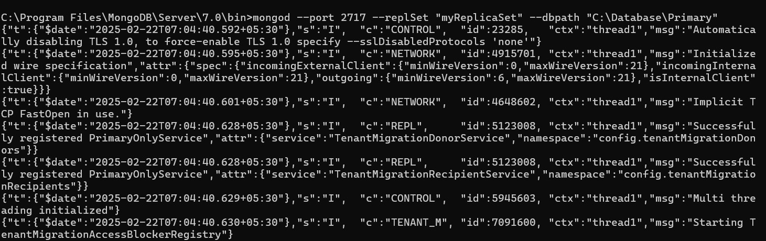

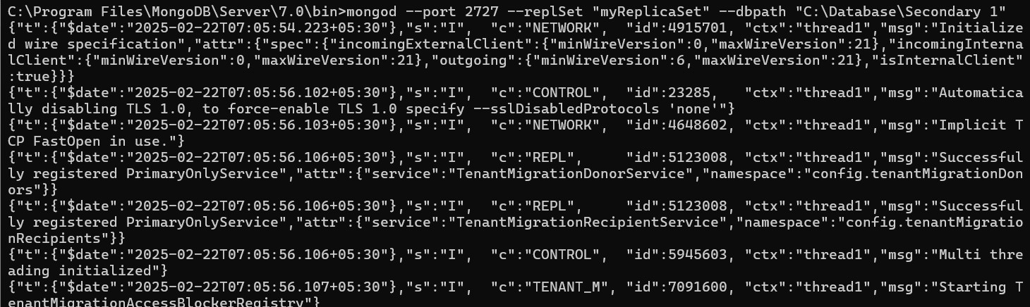

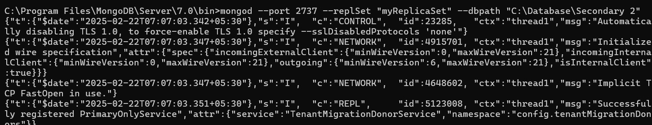

**Step 2: Open cmd from bin and type the below command to connect the primary server:**

>mongosh --port 2717

**Step 3: Initiate the Replica Set.**

-Open same cmd where you have connected the primary server ie from step 2

-Write the below command:

rs.initiate({ _id: "myReplicaSet", members: [ { _id: 0, host: "localhost:2717" }, { _id: 1, host: "localhost:2727" }, { _id: 2, host: "localhost:2737" } ] });

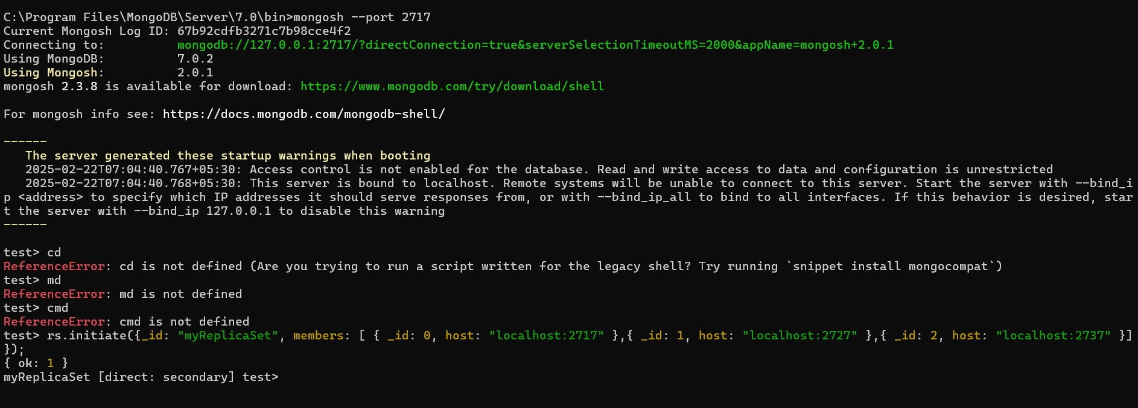

Now,check the status:

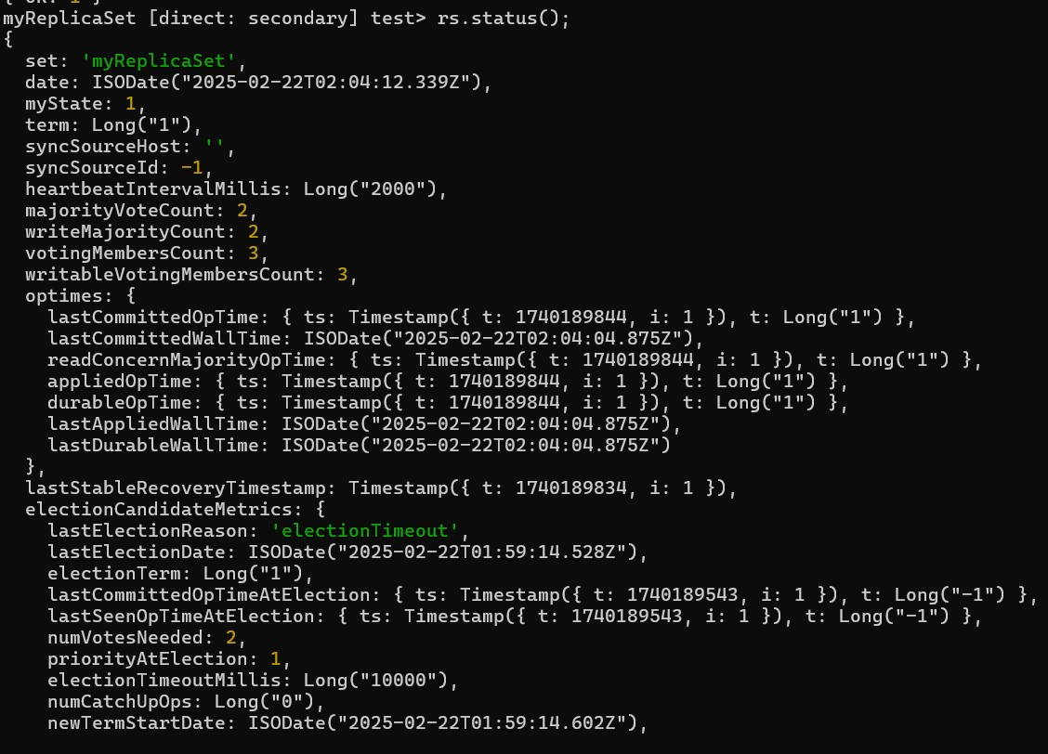

# **SHARDING**

**Step 1: Create Database Folders (Shard1, Shard2, Shard3).**

-Open MongoDB terminal (cmd) from bin, and follow the below commands:

*For Shard1: mongod --shardsvr --port=1130 --replSet="ShardReplSet" --dbpath="C:/data/shard1"

*For Shard2: mongod --shardsvr --port=1140 --replSet="ShardReplSet" --dbpath="C:/data/shard2" *For Shard3 : mongod --shardsvr --port=1150 --replSet="ShardReplSet" --dbpath="C:/data/shard3" #Note: Open three separate cmds for above three servers.

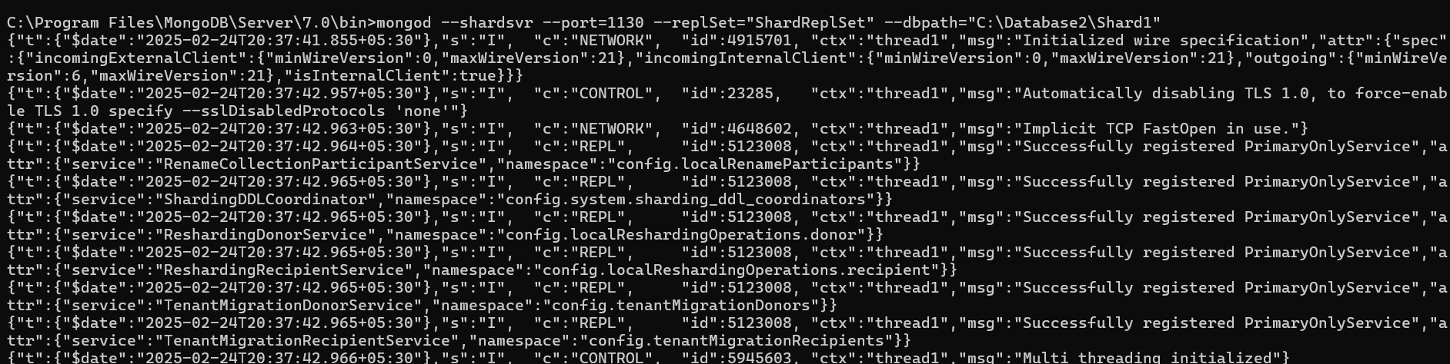

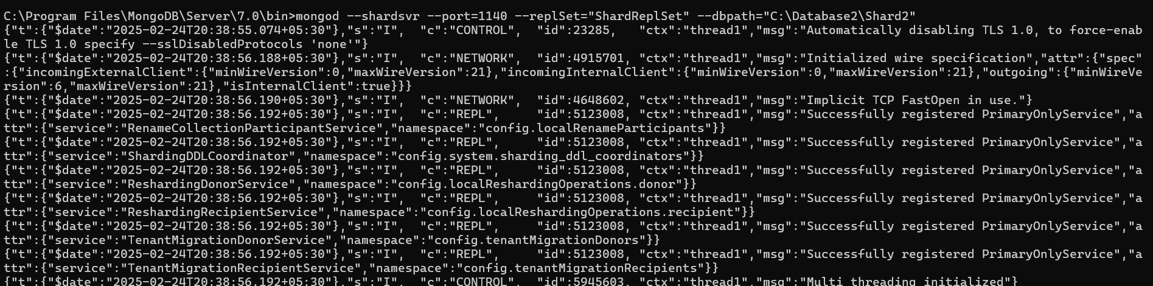

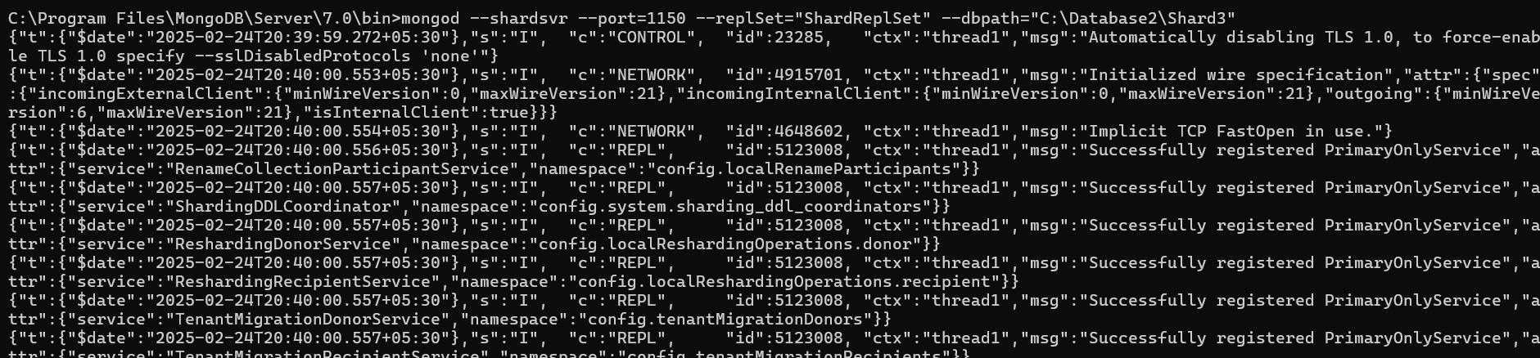

**Step 2: Connect to One Shard & Initiate Replica Set.**

Open MongoDB cmd :

>mongosh --port=1130

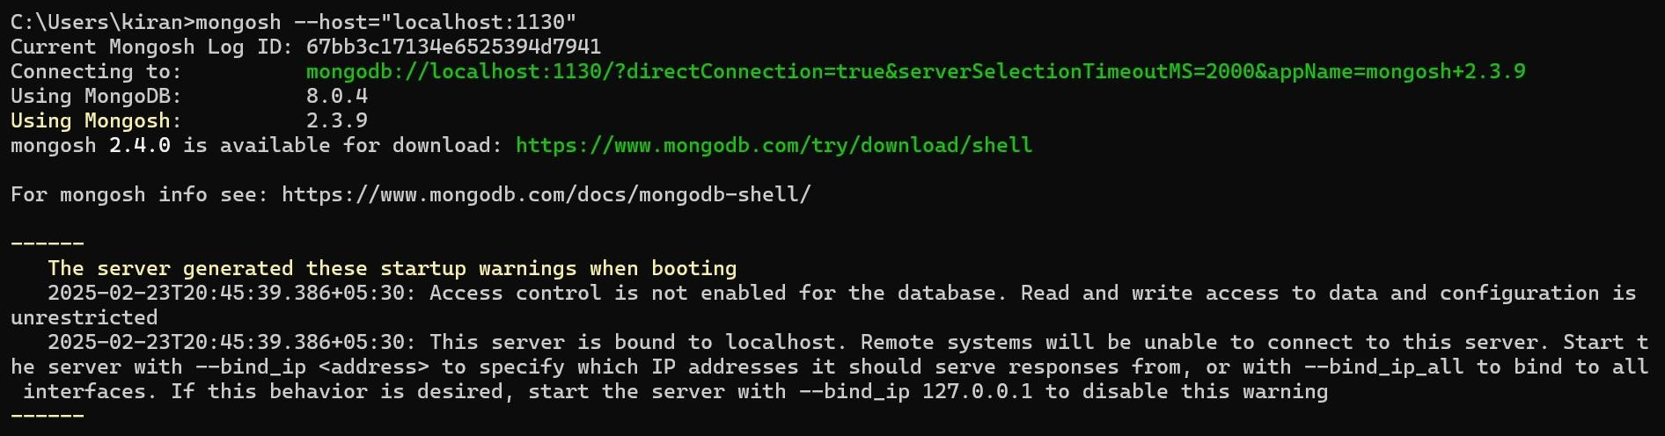

**Step 3: In same cmd Write the js code:**

rs.initiate({

_id: "ShardReplSet", members: [

{ _id: 0, host: "localhost:1130" },

{ _id: 1, host: "localhost:1140" },

{ _id: 2, host: "localhost:1150" }

]

});

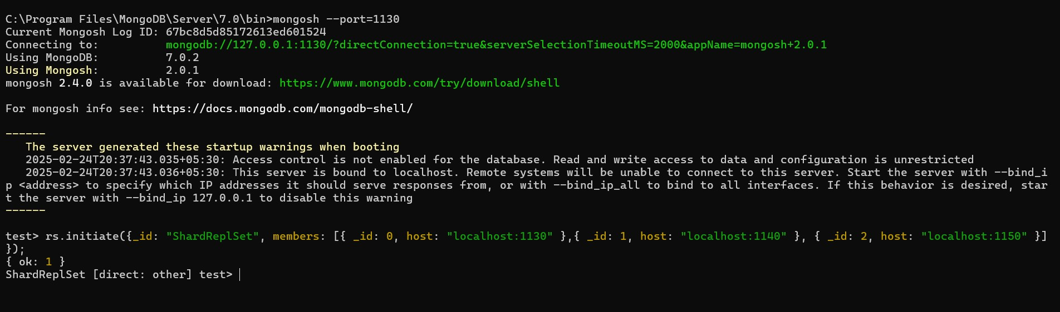

**\*\*Shard Replica Set is ready…**

**Step 4 : Start the Query Router (mongos):**

>mongos --port=1210 --configdb="ConfigReplSet/localhost:1030,localhost:1040,localhost:1050"

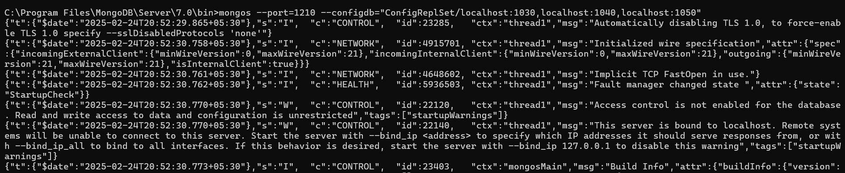

-Query router is ready.

**Step 5: Connect Query Router & Add Shards.**

>mongosh --port=1210

On the same cmd write the code,

>sh.addShard("ShardReplSet/localhost:1130,localhost:1140,localhost:1150");

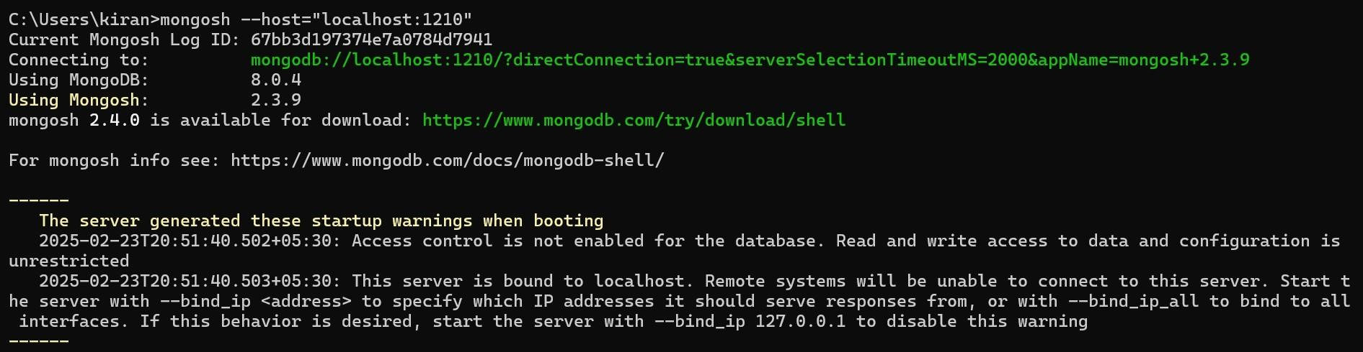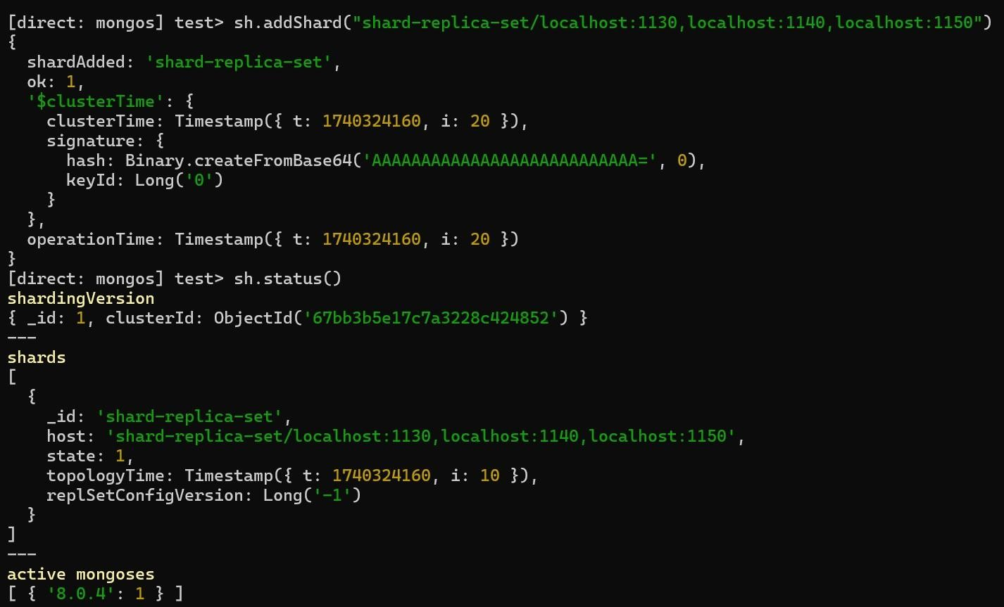

**Step 6: Enable Sharding on a Database**

>sh.enableSharding("practice");

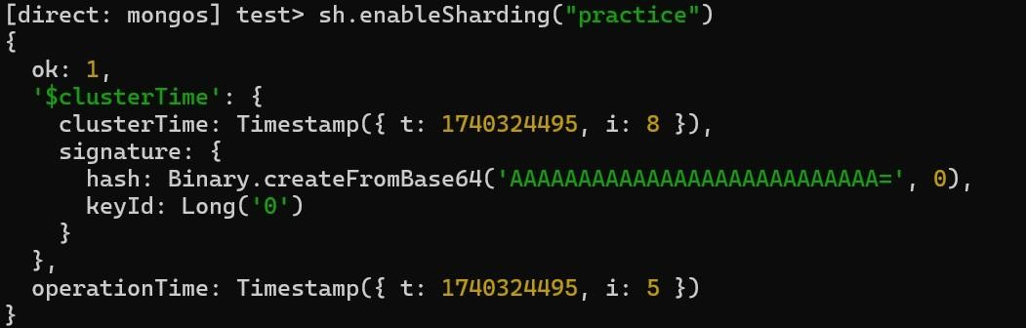

-Sharding enabled for the database practice!

**Step 7: Shard a Collection**

Hashed-based sharding (Random Distribution)

>sh.shardCollection("practice.users", { "userId": "hashed" });

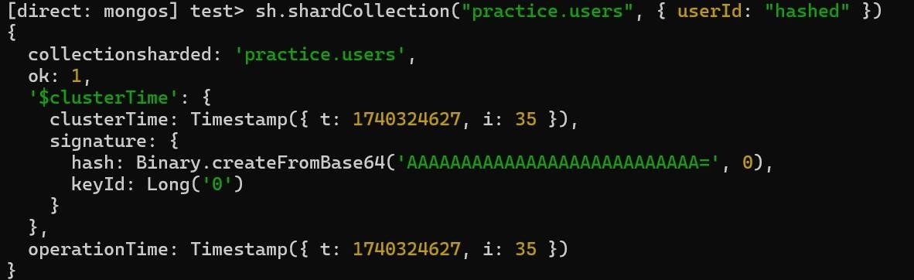

-**Collection students is now sharded!**

## Step 8: Insert Sample Data and Verify

>use practice

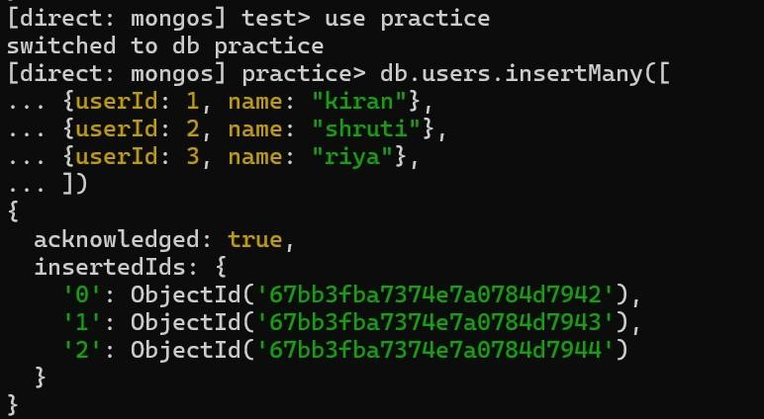

## Step 9: To check where documents are stored

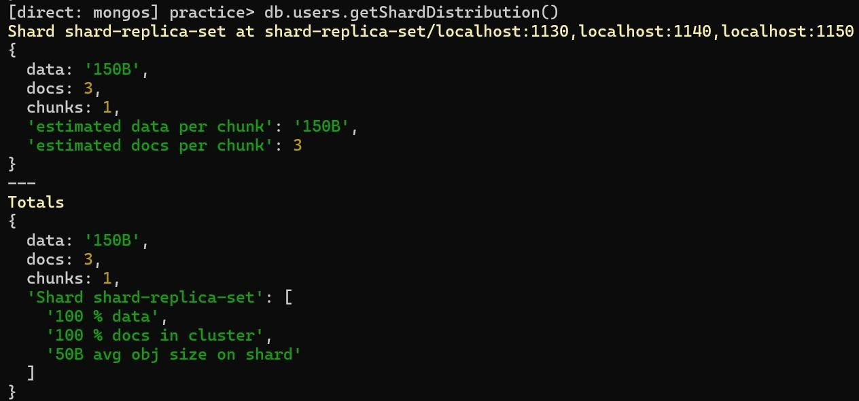

## -To check collection-level sharding

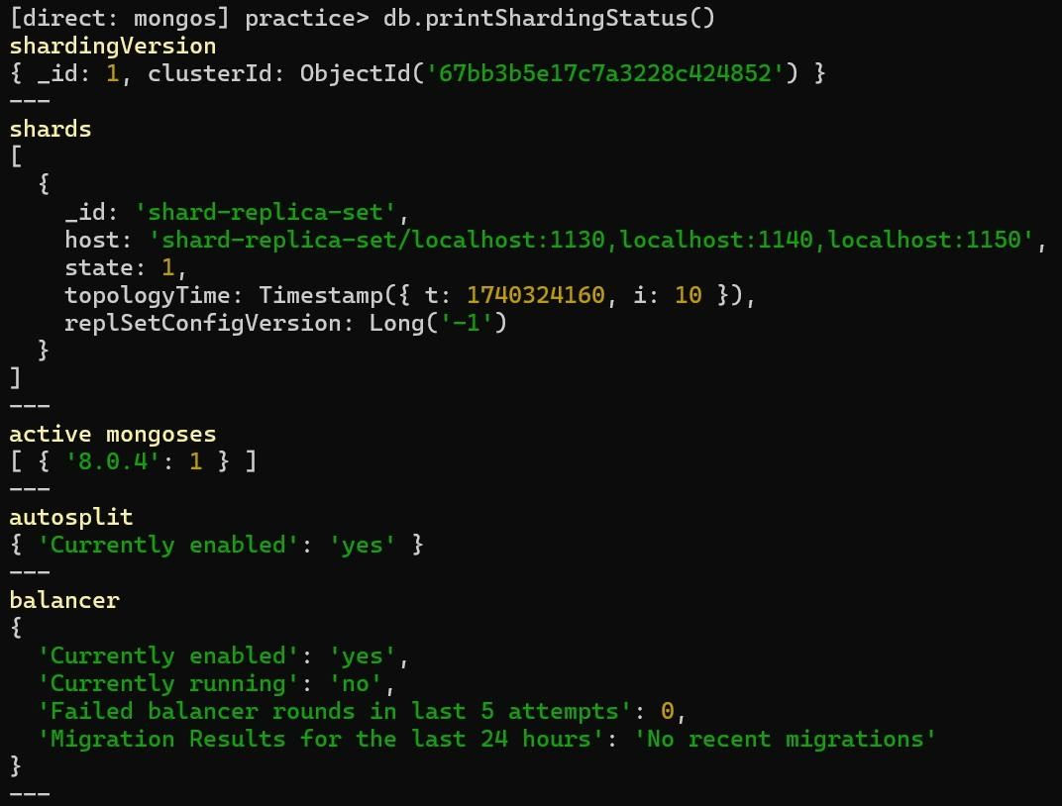

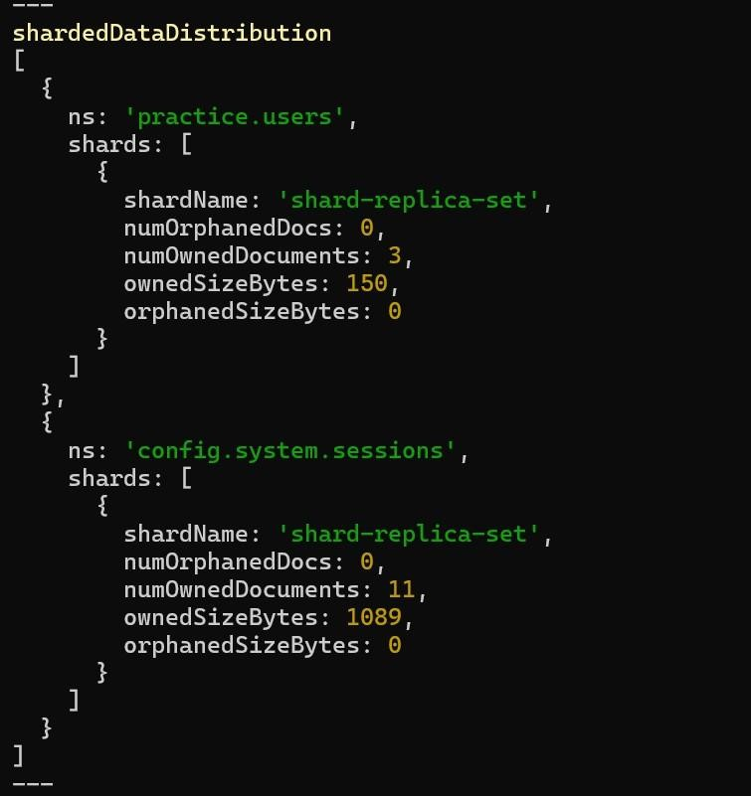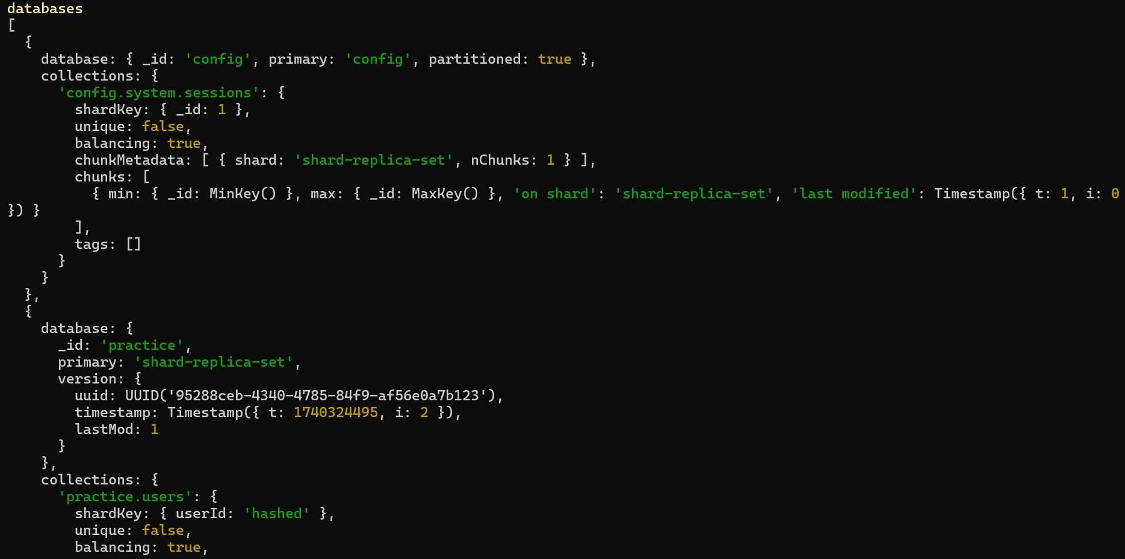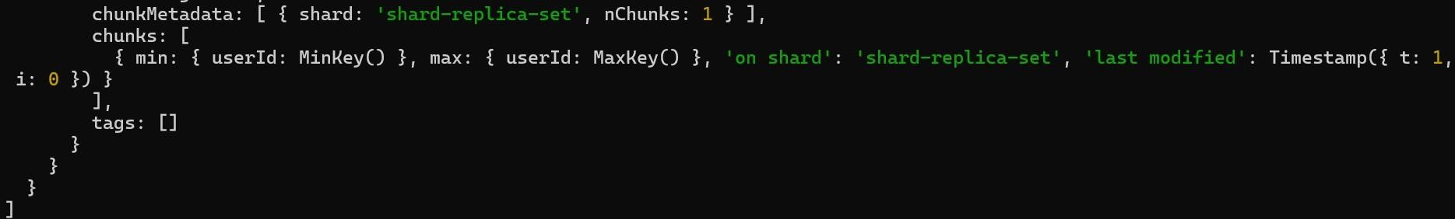

## -To check overall cluster health

